**Department of Electrical and Computer Engineering**

Author: Zainab Hussein

Title: Multicycle Processor (Part 2)

Date: 4-18-2017

1. Time spent: Lab period
2. Attached in last page
3. Datapath code

// The datapath unit is a structural verilog module. That is,

// it is composed of instances of its sub-modules. For example,

// the instruction register is instantiated as a 32-bit flopenr.

// The other submodules are likewise instantiated.

module datapath(input logic clk, reset,

input logic pcen, irwrite, regwrite,

input logic alusrca, iord, memtoreg, regdst,

input logic [1:0] alusrcb, pcsrc,

input logic [2:0] alucontrol,

output logic [5:0] op, funct,

output logic zero,

output logic [31:0] adr, writedata,

input logic [31:0] readdata);

// Below are the internal signals of the datapath module.

logic [4:0] writereg;

logic [31:0] pcnext, pc;

logic [31:0] instr, data, srca, srcb;

logic [31:0] a;

logic [31:0] aluresult, aluout;

logic [31:0] signimm; // the sign-extended immediate

logic [31:0] signimmsh; // the sign-extended immediate shifted left by 2

logic [31:0] wd3, rd1, rd2;

logic [31:0] pcjump;

logic [27:0] shiftjump;

// op and funct fields to controller

assign op = instr[31:26];

assign funct = instr[5:0];

assign pcjump = {pc[31:28],shiftjump};

// ADD CODE HERE

// datapath

flopenr #(32) pcreg( .clk(clk), .reset(reset), .en(pcen), .d(pcnext), .q(pc) );

mux2 #(32) pcmux( .d0(pc), .d1(aluout), .s(iord), .y(adr) );

flopenr #(32) instreg( .clk(clk), .reset(reset), .en(irwrite), .d(readdata), .q(instr) );

flopr #(32) datreg( .clk(clk), .reset(reset), .d(readdata), .q(data) );

regdstmux2 #(32) regDestmux( .d0(instr[20:16]), .d1(instr[15:11]), .s(regdst), .y(wa3) ); mux2 #(32) mem2regmux( .d0(aluout), .d1(data), .s(memtoreg), .y(wd3) );

signext signEXT( .a(instr[15:0]), .y(signimm) );

regfile REGFILE( .clk(clk), .we3(regwrite), .ra1(instr[25:21]), .ra2(instr[20:16]), .wa3(wa3), .wd3(wd3), .rd1(rd1), .rd2(rd2) );

flopr #(32) srcareg( .clk(clk), .reset(reset), .d(rd1), .q(a) );

flopr #(32) srcbreg( .clk(clk), .reset(reset), .d(rd2), .q(writedata) );

mux2 #(32) alusrcamux( .d0(pc), .d1(a), .s(alusrca), .y(srca) );

sl2 immShifter( .a(signimm), .y(signimmsh) );

mux4 #(32) alusrcbmux( .d0(writedata), .d1(32'h0004), .d2(signimm), .d3(signimmsh), .s(alusrcb), .y(srcb) );

alu ALU( .a(srca), .b(srcb), .f(alucontrol), .y(aluresult), .zero(zero) );

sl2 jumpShifter( .a(instr[25:0]), .y(shiftjump) );

flopr #(32) aluoutreg( .clk(clk), .reset(reset), .d(aluresult), .q(aluout) );

mux3 #(32) alucontrolMux( .d0(aluresult), .d1(aluout), .d2(pcjump), .s(pcsrc), .y(pcnext) );

endmodule

1. Simulation waveforms

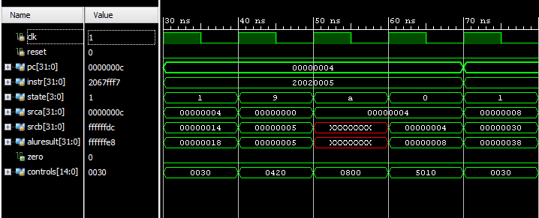

This addi instruction is as expected in the table.

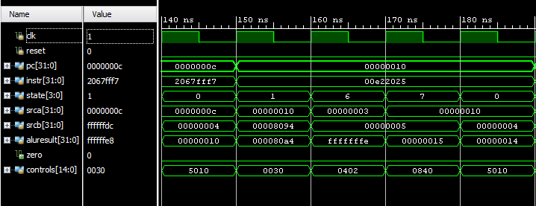

This or instruction is as expected in the table

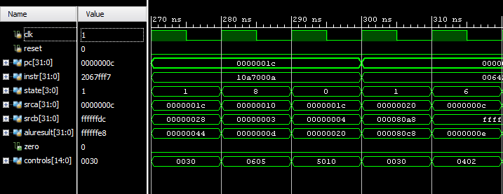

This beq instruction is as expected in the table, and shows the correct transition to the slt instruction.

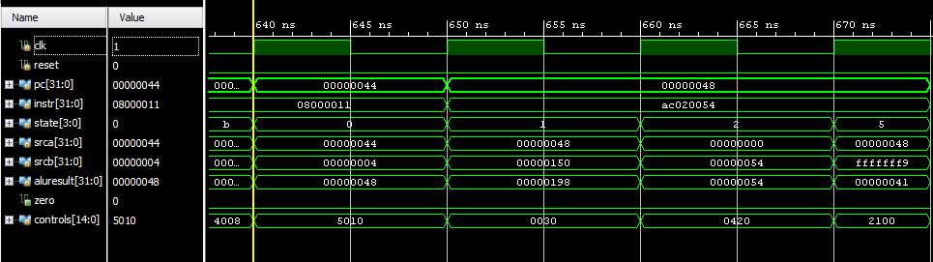

This shows correct transition from the jump to sw instruction, as in the table

1. The results of the simulations match the expected results outlined in the prelab table of instruction trace. Yes the simulation indicates succeeded after I changed the final value at register 84 from 7 to -7.